Cloud Computing/Virtualization Final Project Report

**Instructor: Mousa Ayyash**

**Group Members :**

* Ashwan Kumar Reddy Avula
* Anvesh Gorrepati
* Akifullah Khan
* Anand Kumar Reddy

**Dated: 29 June, 2022**

# Project Overview:

Viva Health is an Indonesia-based coordinated health specialist organization serving the north of 5 million clients across in excess of 142 drug stores in West Java, Central Java, Yogyakarta, East Java, and Bali. Besides medication and healthcare items, 50% of Viva Health's drug stores are likewise incorporated with specialist interview administrations.

To address a developing interest in healthcare online business and teleconsultation administrations in Indonesia, Viva Health looked to modernize its IT framework. In 2019, Viva Health chose to move its SAP Business Suite on HANA to the cloud. Beforehand, it ran SAP on an on-premises infrastructure, making the provisioning of new servers an expensive interaction. Adaptability was likewise an issue. Viva Health experienced incessant blackouts and equipment disappointments, particularly during times of weighty responsibilities. Equipment substitutions frequently required as long as 2 days to show up and a further 2 days to convey. This influenced Viva Health as its creation business needed to work nonstop and couldn't bear the cost of free time.

With assistance from Cloud Comrade, an Amazon Web Services (AWS) SAP Competency Partner, the organization effectively relocated to the AWS Cloud in no less than 4 months, accomplishing close to zero free time and laying the basis for its computerized venture into online business and teleconsultation.

# Why do we choose AWS:

AWS (Amazon Web Services) is an Amazon-gave distributed computing stage that incorporates Foundation-as-a-Service (IaaS), Platform-as-a-Service (PaaS), and bundled administrations. It joins SaaS (Software as a Service) and SaaP (Software as a Product). AWS administrations can be utilized by organizations to acquire PC power, data set capacity and content conveyance. You can utilize Amazon Web Services to arrange processing power, extra room, and other assets (AWS).

An assortment of reliable IT framework administrations to address the issues of your business. Relocate your applications to the AWS cloud for a minimal expense and with little work to get a good deal on equipment furthermore, backing, and the executive's costs.

Business execution, security, and trustworthiness prerequisites. By scattering the server farm across numerous destinations, the organization guarantees that the whole assistance does not go down in that frame of mind of a tempest or other catastrophic event in one of the server farms. We were effective in following through with the job.

Some of the benefits of AWS are as follows:

* Elite execution, speedy sending - If you really want quick application execution and arrangement, the cloud is the most ideal decision.
* Impressive expense management - Your expenses can be controlled since it's a 'pay as you use' situation.
* Nimbleness, adaptability, and bother-free updates - The cloud offers an exceptionally adaptable facilitating arrangement, and procedures for movement would be graphed by the seller, assisting your business with development.
* Increase and decrease according to occasional prerequisites - Enjoy programmed scaling or assets according to request. Once more you really want to pay just for what assets you use.
* Move from enormous CapEx (Capital Expenditure) to stable OpEx (Operating Expenditure) - Accounting costs will be more steady, and this could be valuable during duty and bookkeeping.
* Security - SAP can be secure when it is on-premises. Yet, with work in access control, broad standard encryption, and backing, rumored cloud merchants can likewise give a similar degree of safety.

# SAP on AWS:

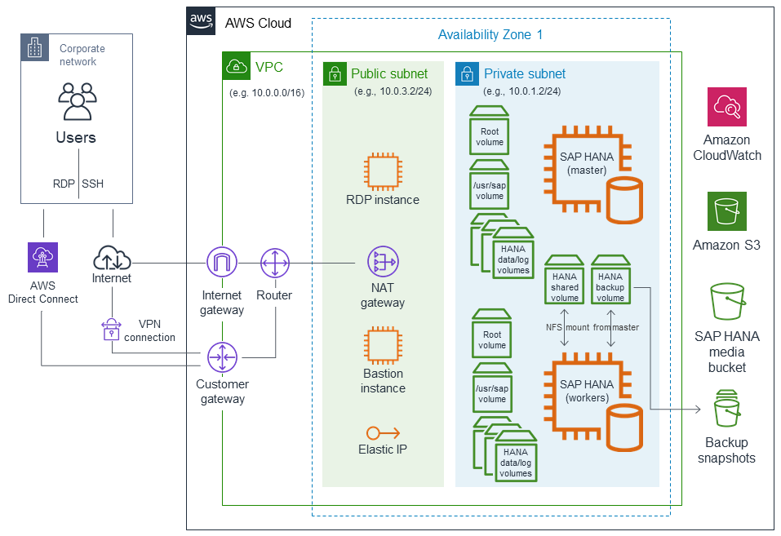Figure 1: Migrating SAP HANA from Other Platforms to AWS


            Backup and restore
          Figure 2: SAP migration to the cloud

**Required AWS Services:**

1. **AWS Direct Connect:**

AWS Direct Connect is a network service that provides an alternative to using the Internet to connect to AWS. With AWS Direct Connect, data previously transmitted over the Internet will be transmitted over a private network connection between your devices and AWS.

1. **Amazon VPN Connect:**

AWS VPN Connect is a client-oversaw VPN administration that permits you to get to your AWS assets as your neighborhood network safely. With AWS Client VPN, you design an endpoint to which your clients can interface and make a protected TLS VPN meeting.

1. **Amazon VPC:**

Amazon VPC empowers you to fabricate a virtual organization in the AWS cloud - no VPNs, equipment, or actual data centers are required. You can characterize your own organization space, and control how your organization and the Amazon EC2 assets inside your organization are presented to the Internet.

1. **Amazon EC2:**

Amazon EC2 eliminates the requirement for us to put resources into equipment forthright, permitting us to create and send applications all the more rapidly, setting aside our organization cost and further improve performance.

1. **Amazon S3:**

Amazon Simple Storage Service (Amazon S3) is an item stockpiling administration that offers industry-driving versatility, information accessibility, security, and execution. You can utilize Amazon S3 to store and recover any measure of information whenever, from anyplace.

1. **Amazon Cloudwatch:**

Amazon CloudWatch is a checking and the management service that gives information and significant experiences to AWS, mixture, and on-premises applications and framework assets.

These are AWS administrations that you can coordinate into your business for hierarchical development and adaptability. Each help has progressed includes and depends on pay-more only as costs arise estimating, which saves cash when the asset isn't in use. You can likewise carry out online business and capacity arrangements utilizing these administrations.

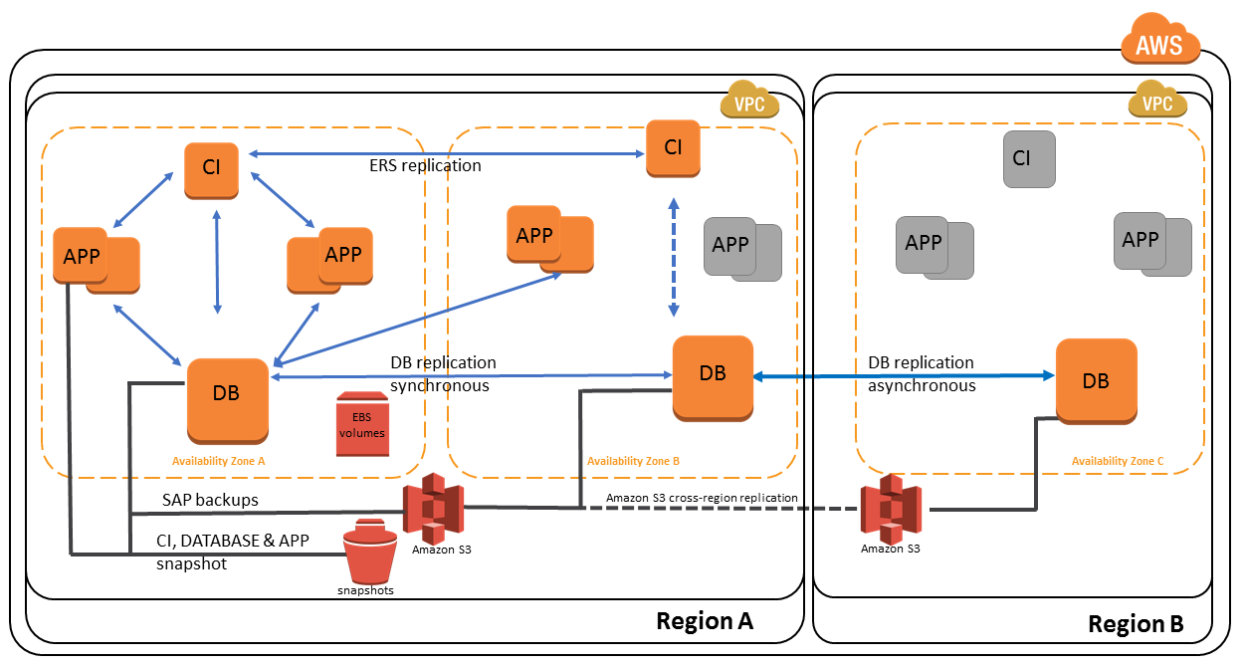

SAP relocation to the cloud happens when organizations move their SAP applications, information, and innovation to oversee cloud administrations. As the relocation is from one stage to a very surprising stage, there are various things to be dealt with.

SAP movements are strategic, consequently, they ought to be finished inside the predetermined time with the base gamble and most extreme adaptability. This gets extraordinary monetary profits since there is a colossal diminishing in working costs and a decrease in the utilization of the foundation. Nonetheless, it is vital to painstakingly design the relocation or probably you will wind up with additional expenses, as opposed to a decent profit from speculation.

# Process of SAP Migration:

**Checking compatibility:**

You want to really take a look at the similarity of your SAP applications, data sets, and working frameworks with that of the cloud merchants. Find out if they can uphold your updates also.

You can likewise investigate the specialized, language principles and administration of the potential cloud seller to your organization's inner norms, and see whether that matches also. Check whether the parts match, and in the event that they have a decent group of IT experts with joining abilities to examine the dangers.

What's more, the seller ought to likewise have the aptitude to eliminate issues and guarantee information wellbeing day in and day out.

**Pay-as-you-go storage space:**

Cloud merchants give you the outright opportunity to pick your capacity size. Nonetheless, you don't need to dive excessively deep into this since you can continuously overhaul or minimize it as the necessity raises or scales down. Yet, this is a stage in relocation and would provide you with a thought of how far you maintain that your business should develop throughout some stretch of time, and when you want to buy additional capacity from the seller. So you apply the typical use strategy, and simply get the specific size you want currently, and afterward develop at whatever point vital.

**Choosing the rightful place:**

Cloud servers are found wherever on the planet, and you can browse any place. Notwithstanding, WAN or Wide Area Network costs will be caused, so it would be fitting to pick an area nearer to home.

The law expresses that cloud specialist co-ops should be straightforward about the area of their server farm servers, yet in the event that you can't find this effectively, you can ask them straightforwardly. All things considered, your applications must be in a protected spot, and near where your clients are. Picking the servers and facilitating the applications nearer to the geological area of your clients would empower them to have extraordinary involvement in your item.

**Selection of the Service:**

One more move toward recall would be the kind of administration for your SAP thing. There are three levels to browse:

Section level set (ES) - The main level is more appropriate for withdrawn adventures. This choice is for negligible SAP and data set benefits predominantly expected for independent SAP plans, preparing frameworks, demos, etc. As it is passage level, most clients test new frameworks, make SAP demos, and direct preparation programs. It is additionally implied for little detached work things.

Improvement administration - Development administration or DS is about SAP and information base help for advancement and quality affirmation, right from the beginning of advancement until it goes live. The cloud seller does this to help clients through the course of execution, the whole progress, and afterward onto full assistance.

Full help - Just as the name means, the merchant offers total support right from the start till the end. There is the full extent of SAP and data set help. You can pick this sort of administration from the cloud seller when you really want more help for more than one framework scene like in ES and DS. Full Service can be extended to incorporate language establishments, SAP client organization, information base revive, etc.

**Planning and Budgeting:**

Budgeting and planning is the upcoming stage in the movement. The better your arrangement, the more straightforward the cloud movement interaction would be. However specialists encourage you to think about merchant costs, it can't lay out the whole picture since it is generally similar to looking at apples and oranges. You should likewise consider the testing expenses, and that would add up.

Notwithstanding, the expense of movement has forever been a significant thought while moving to oversee administrations. However, a few key IT players lean toward consistency of expenses as opposed to decreased costs. Furthermore, that is the advantage of moving to cloud administrations. It involves knowing the amount you are spending, and the worth it is producing for the business. With the consistency of costs a favored decision, it guarantees them that they are putting resources into the perfect locations.

**Testing**

Assuming your data set or innovation runs on an OS that isn't on the cloud, then you should change those, and test them once more. This could occupy a ton of time, consequently a significant part in the relocation cycle. Then again, in the event that your SAP project is simply starting, you can have a nearby execution on the cloud. This cycle would likewise require some investment, so remember that.

**Conclusion:**

Relocating SAP applications to the cloud would be monetarily fulfilling, and infrastructure-wise helpful, with raised degrees of adaptability for wanted capabilities, joined with low working expenses. Notwithstanding, you want to have a decent arrangement close by, and application status is obligatory.

**References:**

1. *Amazon CloudWatch Product Features - Amazon Web Services (AWS)*. Amazon Web Services, Inc. (2022). Retrieved 29 June 2022, from <https://aws.amazon.com/cloudwatch/features/>
2. *Cloud Object Storage – Amazon S3 – Amazon Web Services*. Amazon Web Services, Inc. (2022). Retrieved 29 June 2022, from <https://aws.amazon.com/s3/>
3. *Logically Isolated Virtual Private Cloud—Amazon VPC – Amazon Web Services*. Amazon Web Services, Inc. (2022). Retrieved 29 June 2022, from <https://aws.amazon.com/vpc/>
4. *Hybrid Cloud Network Connections - AWS Direct Connect - Amazon Web Services*. Amazon Web Services, Inc. (2022). Retrieved 29 June 2022, from <https://aws.amazon.com/directconnect/>.
5. *Secure and resizable cloud compute – Amazon EC2 – Amazon Web Services*. Amazon Web Services, Inc. (2022). Retrieved 29 June 2022, from <https://aws.amazon.com/ec2/>.
6. *Amazon Web Service Benefits*. Amazon Web Services, Inc. (2022). Retrieved 29 June 2022, from <https://aws.amazon.com/application-hosting/benefits/>.